# Test cases:

1. **Import Excel:**
   * Steps:
     1. The user can be org admin, Project admin or in house user.
     2. Go to workshop page.
     3. Click on “Import records” button.
     4. Select the file to be imported.
     5. Click on Upload button.

**Result:** The selected excel file is uploaded and the report is also displayed.

**Screenshot:**

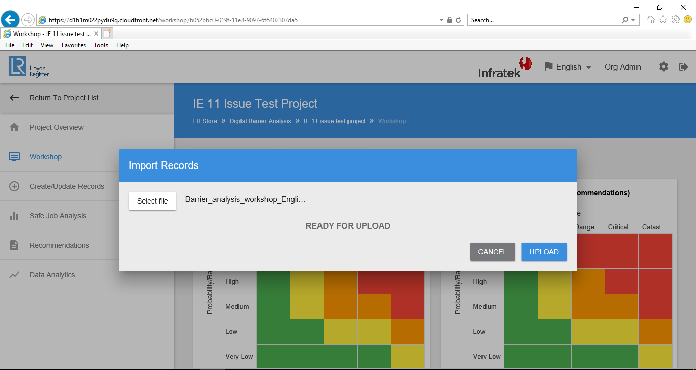

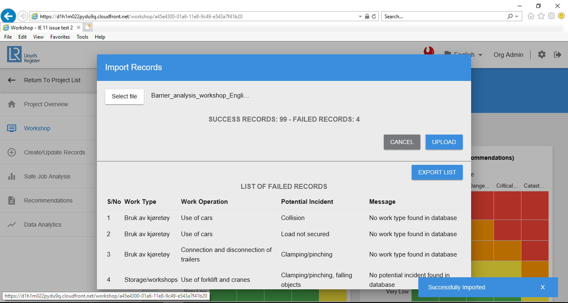

1. **Save as Pdf:**

* Steps:
  + 1. The user can be org admin, Project admin or field user.
    2. Go to Safe job analysis page.
    3. Select a work type and work operation.
    4. Click on “Save as PDF” button.

**Result:** The PDF is of the selected combination of Work type and work operation is downloaded.

**Screenshot:**

